**ER Diagram:**

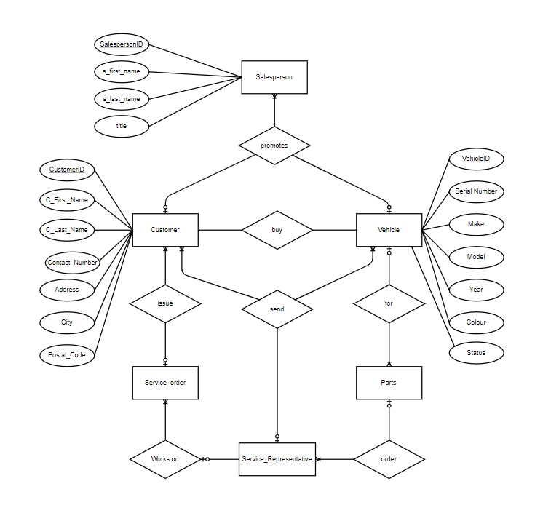

**Tables:**

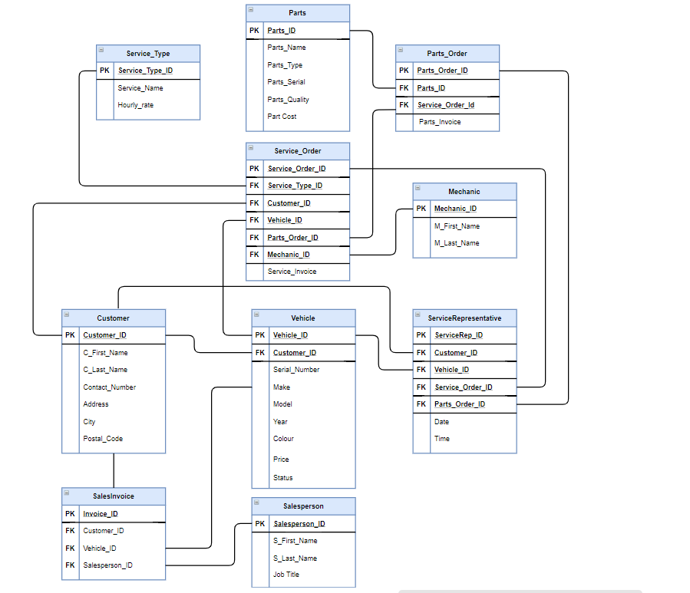

**Table Structure:**

Customer Table

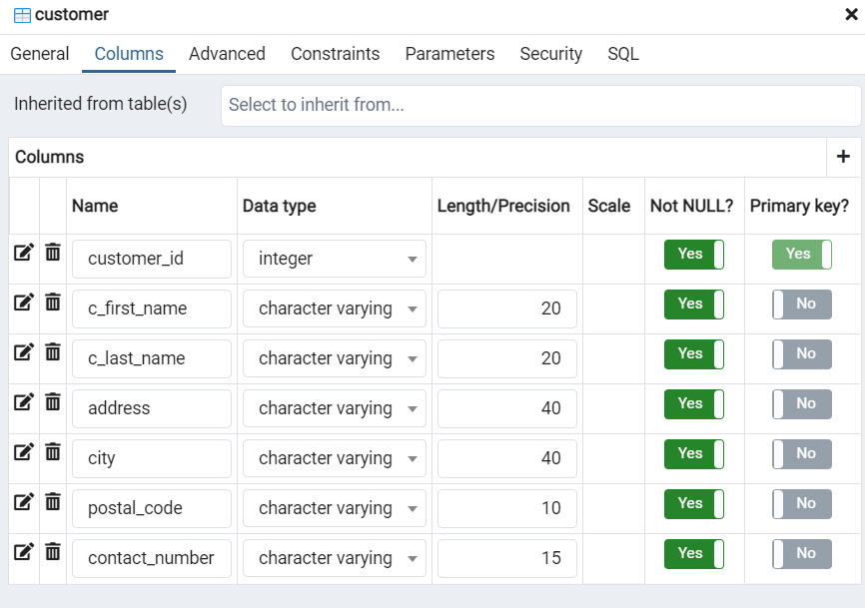

Sales Person Table

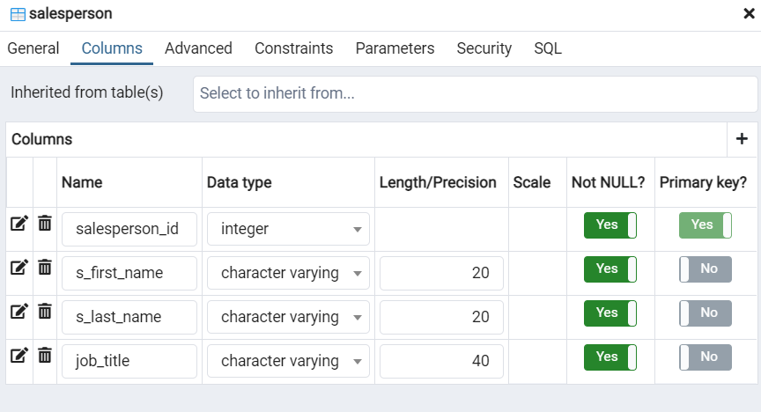

Vehicle Table

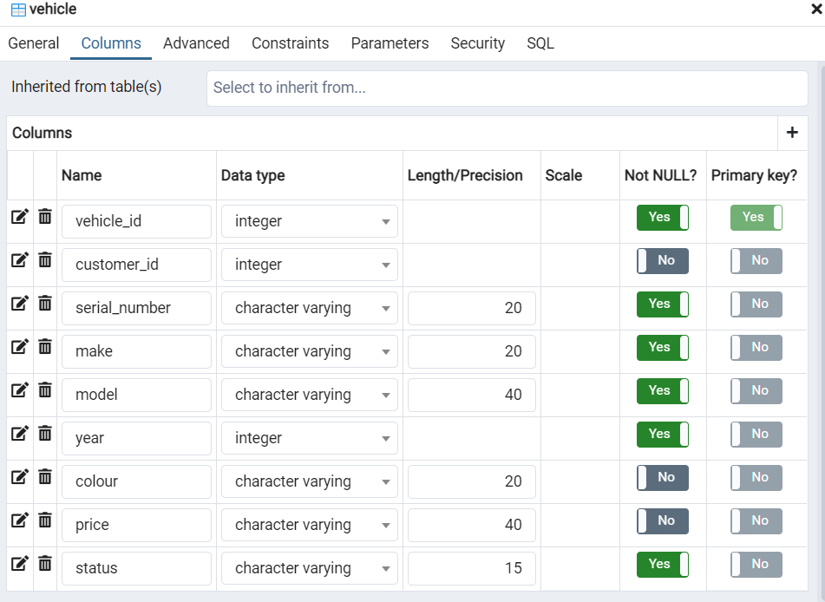

Sales Invoice Table

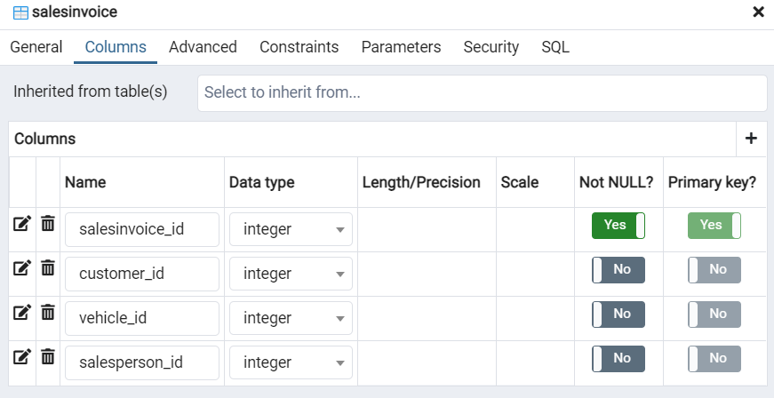

Mechanic Table

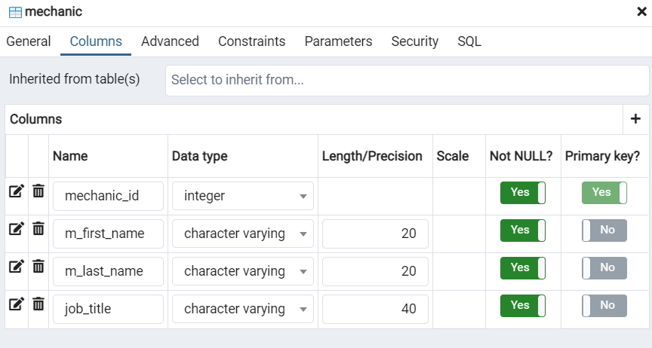

Parts Table

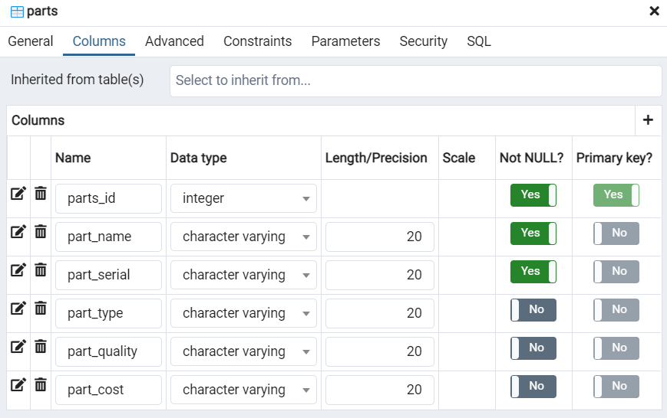

Service Type Table

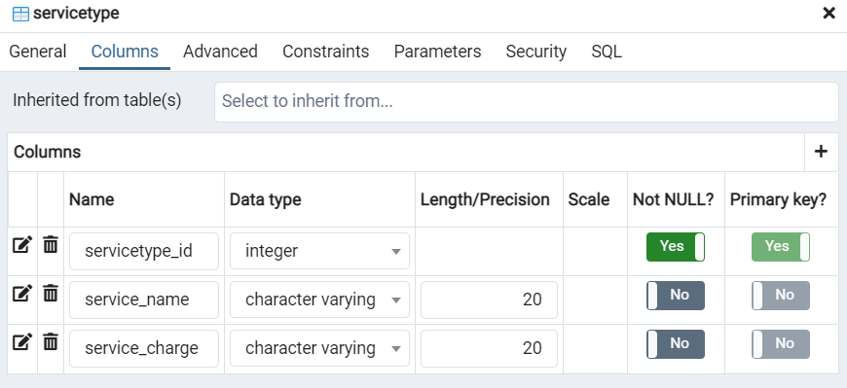

Parts Order Table

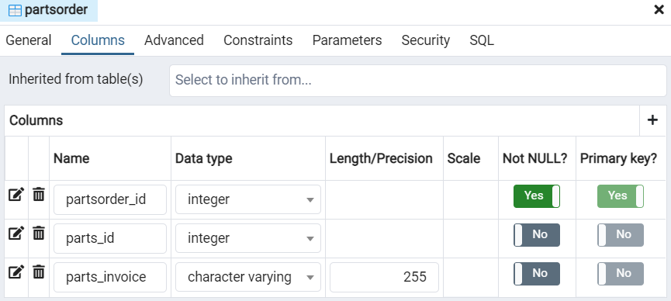

Service Order Table

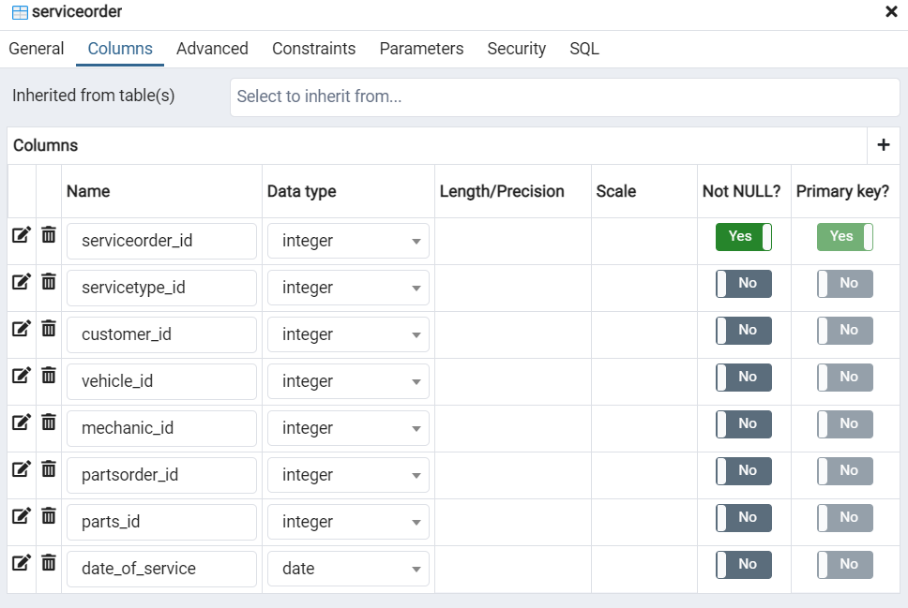

**Creating the tables:**

Customer Table

CREATE TABLE public.customer

(

customer_id integer NOT NULL,

c_first_name character varying(20) COLLATE pg_catalog."default" NOT NULL,

c_last_name character varying(20) COLLATE pg_catalog."default" NOT NULL,

address character varying(40) COLLATE pg_catalog."default" NOT NULL,

city character varying(40) COLLATE pg_catalog."default" NOT NULL,

postal_code character varying(10) COLLATE pg_catalog."default" NOT NULL,

contact_number character varying(15) COLLATE pg_catalog."default" NOT NULL,

CONSTRAINT customer_pkey PRIMARY KEY (customer_id)

)

Sales Person Table

CREATE TABLE public.salesperson

(

salesperson_id integer NOT NULL,

s_first_name character varying(20) COLLATE pg_catalog."default" NOT NULL,

s_last_name character varying(20) COLLATE pg_catalog."default" NOT NULL,

job_title character varying(40) COLLATE pg_catalog."default" NOT NULL,

CONSTRAINT salesperson_pkey PRIMARY KEY (salesperson_id)

)

Vehicle Table

CREATE TABLE public.vehicle

(

vehicle_id integer NOT NULL,

customer_id integer,

serial_number character varying(20) COLLATE pg_catalog."default" NOT NULL,

make character varying(20) COLLATE pg_catalog."default" NOT NULL,

model character varying(40) COLLATE pg_catalog."default" NOT NULL,

year integer NOT NULL,

colour character varying(20) COLLATE pg_catalog."default",

price character varying(40) COLLATE pg_catalog."default",

status character varying(15) COLLATE pg_catalog."default" NOT NULL,

CONSTRAINT vehicle_pkey PRIMARY KEY (vehicle_id),

CONSTRAINT vehicle_customer_id_fkey FOREIGN KEY (customer_id)

REFERENCES public.customer (customer_id) MATCH SIMPLE

ON UPDATE NO ACTION

ON DELETE CASCADE

)

Sales Invoice Table

CREATE TABLE public.salesinvoice

(

salesinvoice_id integer NOT NULL,

customer_id integer,

vehicle_id integer,

salesperson_id integer,

CONSTRAINT salesinvoice_pkey PRIMARY KEY (salesinvoice_id),

CONSTRAINT salesinvoice_customer_id_fkey FOREIGN KEY (customer_id)

REFERENCES public.customer (customer_id) MATCH SIMPLE

ON UPDATE NO ACTION

ON DELETE CASCADE,

CONSTRAINT salesinvoice_salesperson_id_fkey FOREIGN KEY (salesperson_id)

REFERENCES public.salesperson (salesperson_id) MATCH SIMPLE

ON UPDATE NO ACTION

ON DELETE CASCADE,

CONSTRAINT salesinvoice_vehicle_id_fkey FOREIGN KEY (vehicle_id)

REFERENCES public.vehicle (vehicle_id) MATCH SIMPLE

ON UPDATE NO ACTION

ON DELETE CASCADE

)

Mechanic Table

CREATE TABLE public.mechanic

(

mechanic_id integer NOT NULL,

m_first_name character varying(20) COLLATE pg_catalog."default" NOT NULL,

m_last_name character varying(20) COLLATE pg_catalog."default" NOT NULL,

job_title character varying(40) COLLATE pg_catalog."default" NOT NULL,

CONSTRAINT mechanic_pkey PRIMARY KEY (mechanic_id)

)

Parts Table

CREATE TABLE public.parts

(

parts_id integer NOT NULL,

part_name character varying(20) COLLATE pg_catalog."default" NOT NULL,

part_serial character varying(20) COLLATE pg_catalog."default" NOT NULL,

part_type character varying(20) COLLATE pg_catalog."default",

part_quality character varying(20) COLLATE pg_catalog."default",

part_cost character varying(20) COLLATE pg_catalog."default",

CONSTRAINT parts_pkey PRIMARY KEY (parts_id)

)

Service Type Table

CREATE TABLE public.servicetype

(

servicetype_id integer NOT NULL,

service_name character varying(20) COLLATE pg_catalog."default",

service_charge character varying(20) COLLATE pg_catalog."default",

CONSTRAINT servicetype_pkey PRIMARY KEY (servicetype_id)

)

Parts Order Table

CREATE TABLE public.partsorder

(

partsorder_id integer NOT NULL,

parts_id integer,

parts_invoice character varying(255) COLLATE pg_catalog."default",

CONSTRAINT partsorder_pkey PRIMARY KEY (partsorder_id),

CONSTRAINT partsorder_parts_id_fkey FOREIGN KEY (parts_id)

REFERENCES public.parts (parts_id) MATCH SIMPLE

ON UPDATE NO ACTION

ON DELETE CASCADE

)

Service Order Table

CREATE TABLE public.serviceorder

(

serviceorder_id integer NOT NULL,

servicetype_id integer,

customer_id integer,

vehicle_id integer,

mechanic_id integer,

partsorder_id integer,

parts_id integer,

date_of_service date,

CONSTRAINT serviceorder_pkey PRIMARY KEY (serviceorder_id),

CONSTRAINT serviceorder_customer_id_fkey FOREIGN KEY (customer_id)

REFERENCES public.customer (customer_id) MATCH SIMPLE

ON UPDATE NO ACTION

ON DELETE CASCADE,

CONSTRAINT serviceorder_mechanic_id_fkey FOREIGN KEY (mechanic_id)

REFERENCES public.mechanic (mechanic_id) MATCH SIMPLE

ON UPDATE NO ACTION

ON DELETE CASCADE,

CONSTRAINT serviceorder_parts_id_fkey FOREIGN KEY (parts_id)

REFERENCES public.parts (parts_id) MATCH SIMPLE

ON UPDATE NO ACTION

ON DELETE CASCADE,

CONSTRAINT serviceorder_partsorder_id_fkey FOREIGN KEY (partsorder_id)

REFERENCES public.partsorder (partsorder_id) MATCH SIMPLE

ON UPDATE NO ACTION

ON DELETE CASCADE,

CONSTRAINT serviceorder_servicetype_id_fkey FOREIGN KEY (servicetype_id)

REFERENCES public.servicetype (servicetype_id) MATCH SIMPLE

ON UPDATE NO ACTION

ON DELETE CASCADE,

CONSTRAINT serviceorder_vehicle_id_fkey FOREIGN KEY (vehicle_id)

REFERENCES public.vehicle (vehicle_id) MATCH SIMPLE

ON UPDATE NO ACTION

ON DELETE CASCADE

)

**Note:** *For SQL used, please refer to the Text file provided.*

**Select Statements:**

Show which vehicle is brought by the customer bought from which sales representative.

/* select statement to show which customer brought which vehicle via which sales representative*/

select

concat(customer.c_first_name,' ', customer.c_last_name) as customer_name,

vehicle.make,

vehicle.model,

vehicle.price,

concat(salesperson.s_first_name, ' ', salesperson.s_last_name) as salesperson_name

from customer

join salesinvoice

on customer.customer_id = salesinvoice.customer_id

join vehicle

on vehicle.vehicle_id = salesinvoice.vehicle_id

join salesperson

on salesperson.salesperson_id = salesinvoice.salesperson_id

order by customer.customer_id asc;

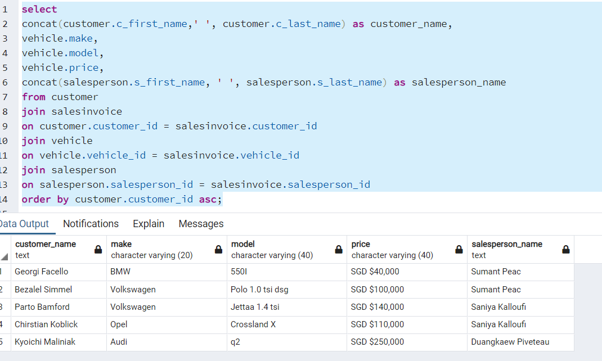

Show the single latest service record of servicing done by the customer

/* select statement to show the single latest service record of servicing done by the customer */

select

concat(customer.c_first_name,' ', customer.c_last_name) as customer_name,

vehicle.make,

vehicle.model,

servicetype.service_name,

concat(mechanic.m_first_name,' ', mechanic.m_last_name) as mechanic_name,

serviceorder.date_of_service

from customer

join serviceorder

on customer.customer_id = serviceorder.customer_id

join vehicle

on vehicle.vehicle_id = serviceorder.vehicle_id

join servicetype

on servicetype.servicetype_id = serviceorder.servicetype_id

join mechanic

on mechanic.mechanic_id = serviceorder.mechanic_id

join partsorder

on partsorder.partsorder_id = serviceorder.partsorder_id

join parts

on parts.parts_id = serviceorder.parts_id

group by customer_name, vehicle.make,vehicle.model,servicetype.service_name,mechanic_name,serviceorder.date_of_service

order by serviceorder.date_of_service desc

LIMIT 1;

